

Plus 8 Page Tabloid on App Savvy Bangladesh

DHAKA THURSDAY MAY 30, 2024

Regd No. DA 781 VotXXXIV No. 130 Jamsamha 16 BS www.thedailystar.net ZbQND 21.144 16 Page Plus Rising Start: Tk 15.00

Metrorail is making our day to day life easier- Passengers

P7

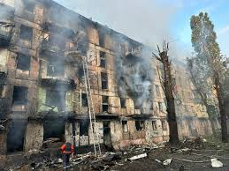

Third tranche

Of IMF loan may

Come in June

B1

Price hike has made general people’s life miserable

P3

Ukraine is again affected by Russian army.

P11



**Won’t tolerate corruption, warns PM**

New School Curriculum

**Implementation**

**Limps Along**

**Mohammad Amir, Staff Reporter**

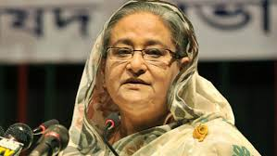

A new school curriculum is being introduced in phases, and the initial experience has left many students, teachers and parents confused and apprehensive. So, the question is, will the new curriculum be a new opportunity for much needed improvement in teaching and learning, or is this an ill-planned and failed reform?

Educationists say the skill-focused curriculum is a positive step forward but the lack of enough training for teachers and logistical support for educational institutions for its successful implementation remain as concerns.

The National Curriculum and Textbook Board (NCTB) introduced a competency-based curriculum for classes one, six and seven in 2023 with a plan to incorporate all the classes up to 10 by 2025.

**Next at p11**

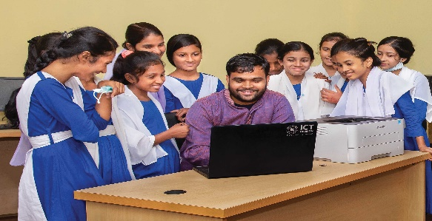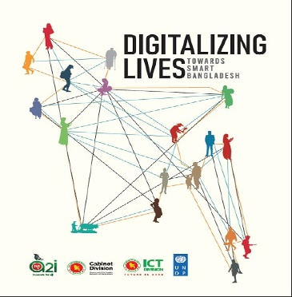

**Quality human resource key to development of ICT sector**

Bangladesh is a riverine country. According to Bangladesh Water development board (BWDB) about 907 river flow in Bangladesh (during summer and winter)...

**Next at p11**

ARE RIVERS IN BANGLADESH OKAY?

**“I’ll Retire Soon”**

**Shakib Posted on His Facebook Yesterday**

We'll never tolerate this (corruption), all will be held responsible for their own duties, and all have to perform their duties properly.

**Next at p12**

"When we talk to tech firms, they say they are facing manpower crunch and when we talk to the academia, they say their graduates are not finding jobs," said Abu Issa Mohammad Mainuddin, executive director of the BASIS.

Mustafa Jabbar, post and telecom minister; Nasrul Hamid, power, energy and mineral resources minister, and Zunaid Ahmed Palak, state minister for ICT, also spoke.

The national budget for the fiscal year of 2024-25 is going to be presented in parliament on Thursday.

**Next at p06**

Palestinian resistance group Hamas claimed Wednesday to have killed eight Israeli soldiers in attacks in Rafah in the southern Gaza Strip.

The group’s armed wing, the Qassam Brigades, said four soldiers were killed and several others injured in an ambush near a school in al-Shawka neighborhood in eastern Rafah.

Hamas fighters also shot dead three Israeli soldiers in the area, the group said.

**Next at p11**